Date | 03 October 2026
Team ID | SWTID-2026-7735
Project Name | Auto Ticket Classification using Flow Designer
Maximum Marks | 4 Marks

Project Design Phase-II
Technology Stack (Architecture & Stack)
Technical Architecture:
The deliverable includes the architectural diagram below and the specifications in Table 1 and Table 2.
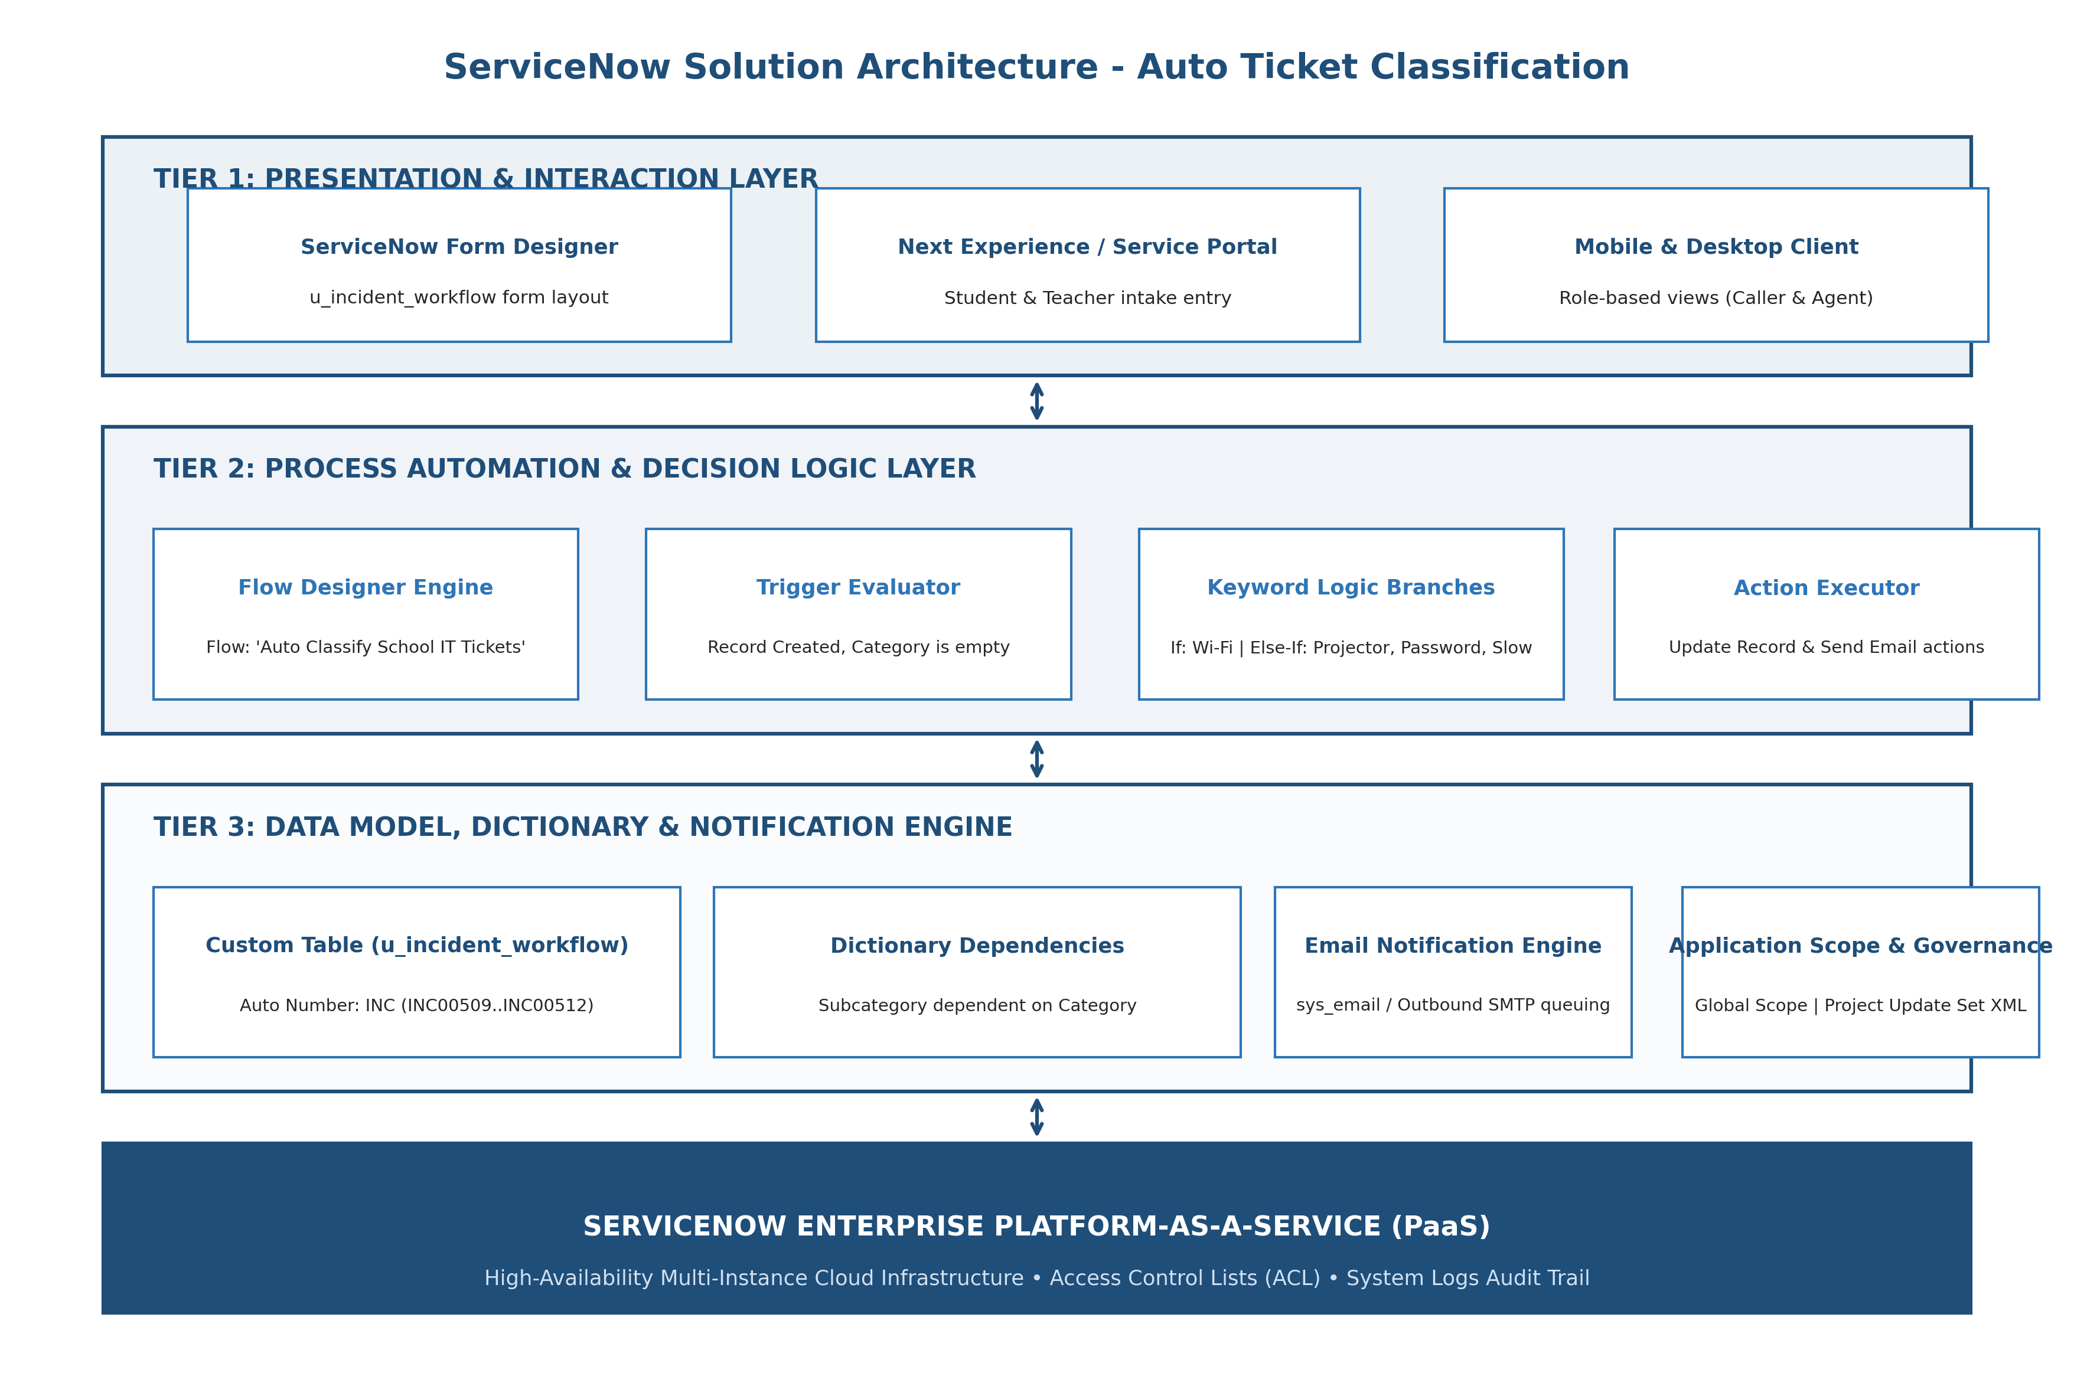
Figure 2.3: ServiceNow Enterprise Technology Stack & Tiered Architecture Diagram
Table-1 : Components & Technologies:
S.No | Component | Description | Technology
1 | User Interface (UI) | Form interface for student and teacher ticket submission | ServiceNow Form Designer / Next Experience UI
2 | Process Automation Engine | Evaluates creation triggers and executes flow logic | ServiceNow Flow Designer (Process Automation)
3 | Decision Logic Engine | Parses keywords in Short Description and updates records | Flow Designer Natural Condition Builder & Data Pills
4 | Database & Schema | Relational database storing incident records and metadata | ServiceNow MariaDB/MySQL Relational Database
5 | Custom Data Model | Structured entity storing school IT tickets with Auto-Numbering | Custom Table: u_incident_workflow (Global Scope)
6 | Dictionary & Taxonomy | Field relationships and hierarchical dependent choices | ServiceNow System Dictionary (sys_dictionary & sys_choice)
7 | Notification Engine | Generates and sends automated email receipts to callers | ServiceNow Email Engine (sys_email) & SMTP Server
8 | Access Control & Security | Controls table read, write, and create permissions | ServiceNow Access Control Lists (ACLs) & RBAC
9 | Application Scope | Execution sandbox and deployment scope | Global Application Scope
10 | Deployment & Migration | Captures all customization records for transport | ServiceNow Local Update Sets & XML Exporter
11 | Cloud Infrastructure | Enterprise multi-instance cloud hosting platform | ServiceNow Cloud Datacenter Infrastructure
Table-2: Application Characteristics:
S.No | Characteristics | Description & Technology Implementation
1 | No-Code Platform Framework | The solution completely avoids hardcoded JavaScript business rules, using Flow Designer visual logic.
2 | Security & Governance Implementation | Enforces Role-Based Access Control (RBAC). Update Set tracking ensures clean XML migration.
3 | Scalable & Reliable Architecture | Asynchronous trigger processing handles sudden bursts of ticket submissions during peak school hours.

